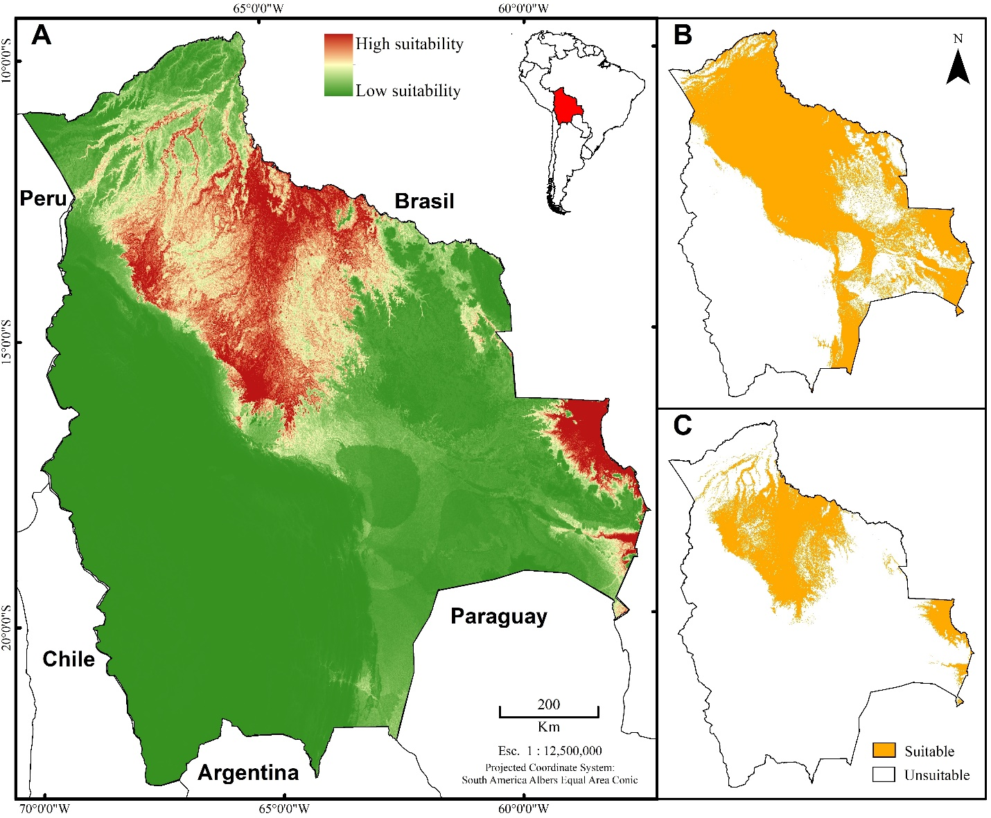

**Figure A.1** Maxent model estimation of potential suitable habitat for *Caiman yacare* distribution in Bolivia using default parameter settings. We present suitable estimates using continuous, independent-threshold models reflecting low (in green) to high (red) potential suitability. Dependent-threshold models were estimated using the Minimum Calibration Training Presence (MCTP) and the 10th percentile Calibration Training Presence (10%CTP) as cut-off thresholds to define suitable (in orange) and unsuitable (in white) regions.